INCOME TAX LESSON NAME DATE
Tax is a mandatory payment made by individuals and corporations to government. It can be levied upon things such as income, property, and sales. Taxes are used to support the government and the programs and services it provides.
History of Tax:
Since the beginning of recorded history, some kind of tax system has existed in organized societies and governments. Over 3,500 years ago, the ancient Egyptians collected taxes and the Roman Empire had a highly evolved tax system.
The French and Romans of the 13th century were credited with the first use of a word similar to tax. The French had taxer and the Latin used taxare to describe the acts: to estimate, to assess, or to touch repeatedly.
Milestones in Canadian taxation
Before 1650 – The colonial governments collected taxes and sent them to the two mother countries, England and France. The colonial governments usually collected revenue by charging customs duties.
1650 – Louis XIV of France imposed the first recorded tax in Canadian history. It was an export tax of 50% on beaver pelts and 10% on moose hides leaving his colonies.
1867 (Collecting) – The British North America Act was passed, allowing the Canadian government to raise money by taxation. In the next 50 years, the federal government used only indirect taxes such as customs duties and excise taxes to raise the money it needed. Direct taxation such as property taxes and income taxes was imposed by the provinces.
1867 (Spending) – The Fathers of Confederation divided the governmental responsibilities of this new country between the federal and provincial governments. The most expensive areas of responsibility – building railways, roads, bridges, and harbours went to the federal government. The provincial governments were responsible for education, health, and welfare.
1914 – August 4, Britain declared war on Germany and, as a British colony, Canada joined in the Great War at Britain’s side. The pressures of financing World War I soon brought major changes to the Canadian tax system.
1916 – The federal government used a new method of direct taxation by starting a corporation tax known as the business profit war tax. It affected corporations only if their profits were more than a certain percentage of their invested capital. Although this was not income tax as we know it today, it was a milestone in the history of Canadian taxation.
1917 – The federal government, led by Sir Robert L. Borden, introduced the Income War Tax Act. Sir Thomas White, Minister of Finance, said: “I have placed no time limit upon this measure . . . a year or two after the war is over, the measure should be definitely reviewed.”
In July 1917 – The federal government imposed a general tax on corporate and personal income that was collected by the Department of Finance.
1927 – The Department of National Revenue was created.
1950s – At this time, the department processed tax returns by hand, which took a lot of time. Gradually, computers came onto the scene and programs were developed to process the returns.
1952 – For the first time, the Department of National Revenue became involved in an area other than income tax when it began to collect old age security tax on personal and corporate income. The Department assessed this tax under the Old Age Security Act.
1991 – The federal government replaced the federal sales tax with the goods and services tax (GST).
2007 – The Government of Canada introduced the Taxpayer Bill of Rights, which outlines what a taxpayer can expect from the CRA.
Taxes collected and paid:
The government collects taxes to pay for the facilities, services, and programs that it provides. We pay taxes on our income and most goods and services. Canada's tax system pays for such things as roads, education, health care, national defense, police and fire services, parks and playgrounds, libraries, garbage collection and many other programs and services.
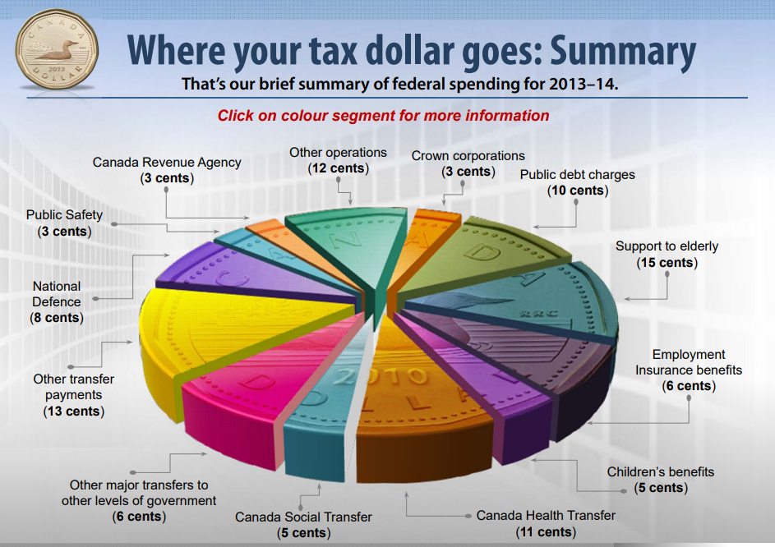
Tax revenue also helps redistribute wealth to benefit lower-income families, students, seniors, and people with disabilities. Tax revenue funds social programs such as old age security, Canada child tax benefit, universal child care benefit, and working income tax benefit.
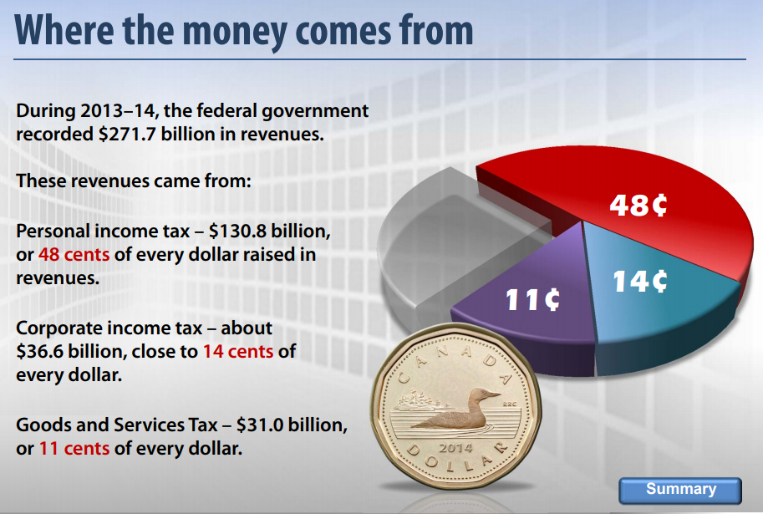
Characteristics of a tax system
A tax system needs to benefit all, and it should be flexible so the government can use it to achieve specific social and economic objectives.
A tax system is defined by six characteristics:
- who pays the tax;
- the tax base;
- the rates to be applied to the base;
- general exemptions;
- general deductions; and
- other measures, such as how tax is to be paid.
These characteristics determine how much revenue is produced, how fair the tax system is, and its ability to produce economic growth.
Canada's tax system is based on the principle of self-assessment, which means that taxpayers complete their tax return each year to report their income and to calculate whether they owe tax or receive a refund. It is considered the most economical and efficient way to collect income tax.
GST:
The goods and services tax (GST) is a 5% tax that applies to most goods and services in Canada. In some provinces, there are two taxes: the GST and a provincial sales tax (PST). In New Brunswick, Newfoundland and Labrador, Nova Scotia, Ontario, and Prince Edward Island, the GST and PST are combined to form the harmonized sales tax (HST).
We pay GST/HST on most of what we purchase, except:
- basic groceries;
- prescription drugs and medical devices;
- most healthcare, medical, and dental services;
- residential rents, including university residences and boarding houses;
- residential housing other than new;
- local or municipal bus services and passenger ferry services;
- legal aid services;
- most banking services; and
- most educational services including tuition fees.
Types of Taxes:
Taxes are either direct or indirect.
Direct taxes are paid by the taxpayer directly to the government. They include personal income tax, property tax, corporate tax, and estate tax.
Indirect taxes are paid by the taxpayer to a third-party (such as a retail store) who remits the tax to the government. They include sales tax, goods and services tax (GST), harmonized sales tax (HST), fuel tax, and tobacco tax.

SOCIAL INSURANCE NUMBER

What is a SIN number? How can I apply for a SIN number?

- The Social Insurance Number (SIN) is a nine-digit number that you need to work in Canada or to have access to government programs and benefits.
- Service Canada offers the Newborn Registration Service, which is an integrated birth registration and SIN application process. This service is available for parents living in any of the provinces.
- Service Canada requires individuals to apply in-person. By doing so, if your application is in order, you can obtain your SIN in less than 15 minutes and do not need to part with your original proof of identity documents.
- To apply for your SIN, please visit a Service Canada Centre with your original proof of identity documents.

Answer YES or NO, if you should give out your Social Insurance Number.
When proving your identity (except for specific government programs)
To your employer
Completing a job application before you get the job
Completing an application to rent a property
Negotiating a lease with a landlord
Financial institutions from which you earn interest or income (for example, banks, credit unions)
Completing credit card application
Cashing a cheque
Applying for a video club membership
Applying for social assistance benefits
Completing some banking transactions (mortgage, line of credit, loan)
Completing a medical questionnaire
Renting a car
Employment Insurance (EI) program benefits
Subscribing to long-distance or cellular telephone services
Writing a will
Child support payments
Applying to a university or college.
Service Canada gives out the falling warning about SIN fraud:
If your SIN falls into the wrong hands, it could be used to obtain personal information and invade your privacy. When the SIN is not linked to you as its rightful owner, another person could receive your government benefits, tax refunds or bank credits. Furthermore, your personal information could be revealed to unauthorized people. This could lead to identity theft and other types of fraud.
If someone uses your SIN to work illegally or to obtain credit, you may suffer hardship. You could be requested to pay additional taxes for income you did not receive or you could have difficulty obtaining credit because someone may have ruined your credit rating.
List 5 ways can you protect yourself from this type of fraud?
List 4 ways you can protect your personal information (in paper or online).

FILE INCOME TAX-
- Create an account here https://turbotax.intuit.ca/personal-tax-software/free-online.jsp
- File Catherine’s income tax

WHO should file income tax?
- You must file a return each year if any of the following situations apply:
  - You have to pay tax for the year.
  - We sent you a request to file a return.
  - You have to contribute to the Canada Pension Plan (CPP). This can apply if the total of your net self-employment income and pensionable employment income is more than $3,500. See line 222.
  - You are paying employment insurance premiums on self-employment and other eligible earnings. See lines 317and 430. (Accumulated EI hours in case you need to file in the future (you will need 900 EI insurable worked hours)
  - If you ever want a loan from a financial institution

Even if none of these requirements apply, you can file a return if any of the following situations apply:
  - You want to claim a refund.
  - You want the GST/HST credit (including any related provincial credits). For example, you may be eligible if you turn 19 before April.
  - If you have a child and want to receive Canada child tax benefitpayments.
  - You want to carry forward or transfer the unused part of your tuition, education, and textbook amounts.
  - You want to report income for which you could contribute to an RRSP to keep your RRSP/PRPP deduction limit for future years current.

How big is Canada’s underground economy? $42 billion

- What is the underground economy? Canadian Business magazine defines it as “market-based economic activities, whether legal or illegal, that escape measurement because of their hidden, illegal or informal nature.”
- 2.3% of GDP (in a zero growth economy, this is a big difference!)
- The residential construction industry is the key culprit,
accounting for 28.3% of total.
- Why is this a problem?
  - Business that don’t pay taxes not competing fairly with their prices.
  - “FREE RIDERS” exist, letting the rest of us pay to support the tax-funded services that we all enjoy.
  - If you don’t pay your share, you’re not stealing from the government—
    - you’re stealing from the rest of us (slide 5)

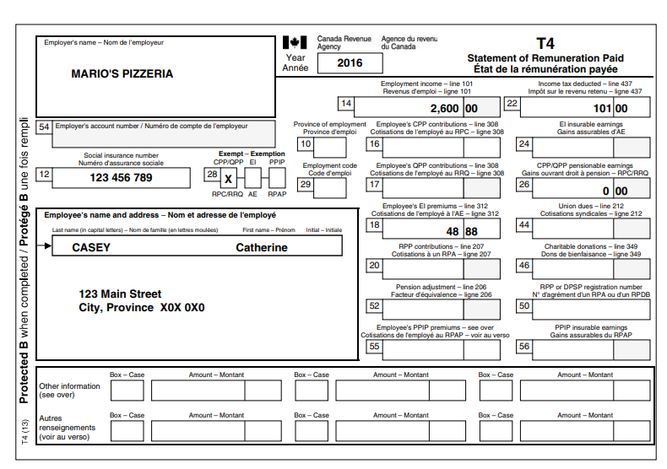

Refund? ________________________________

How much?
________________________________
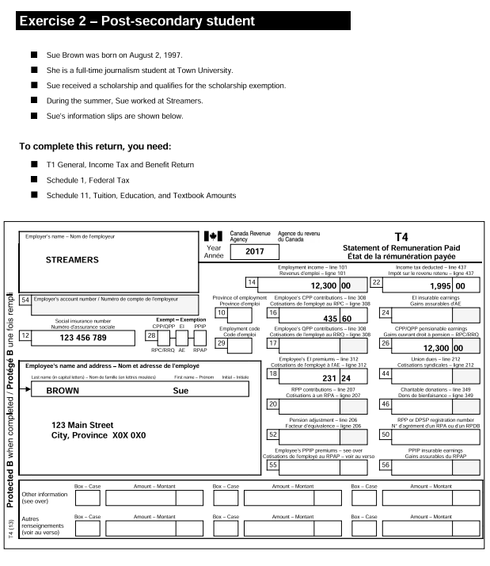

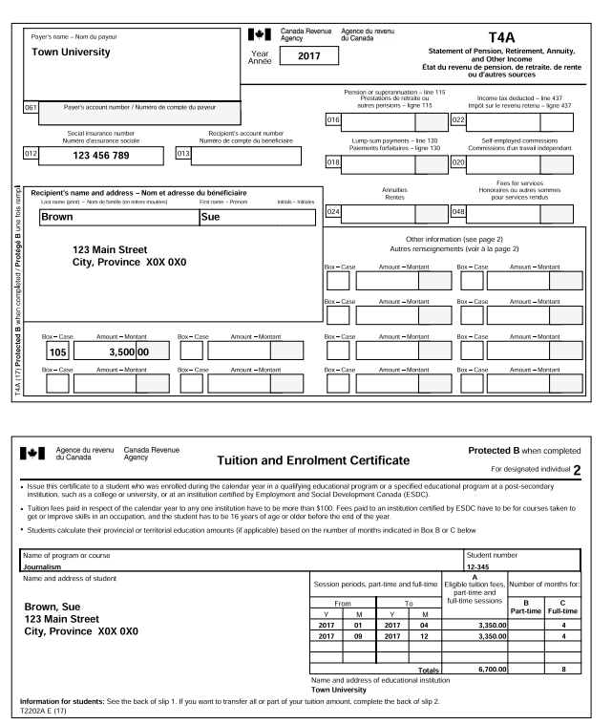

Refund? ________________________________

How much?
________________________________

